**Model Development Phase**

|  |  |
| --- | --- |
| Date | 22 June 2025 |
| Team ID | SWTID1749918275 |
| Title | Bulls Eye Target Detection using Transfer Learning |
| Maximum Marks | 4 Marks |

**Initial Model Training Code, Model Validation and Evaluation Report**

The initial model training code will be showcased in the future through a screenshot. The model validation and evaluation report will include classification reports, accuracy, and confusion matrices for multiple models, presented through respective screenshots.

**Initial Model Training Code**

The model was trained using MobileNetV2 as the base architecture with the following configuration:

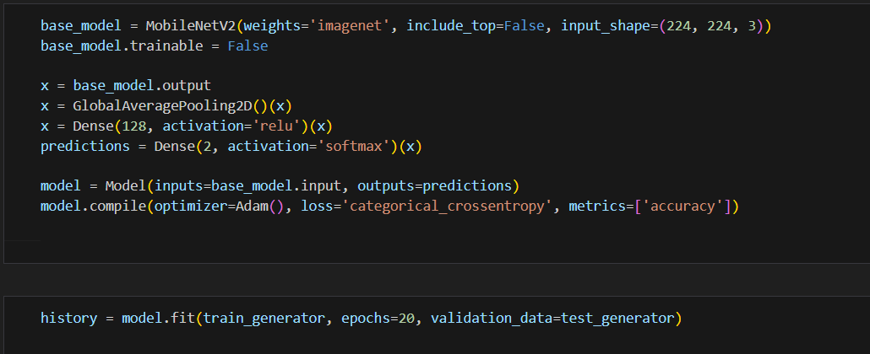

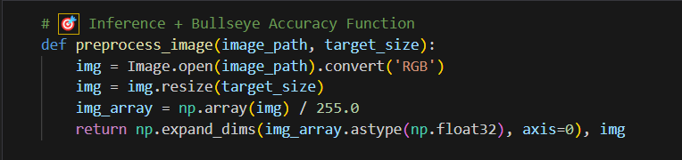

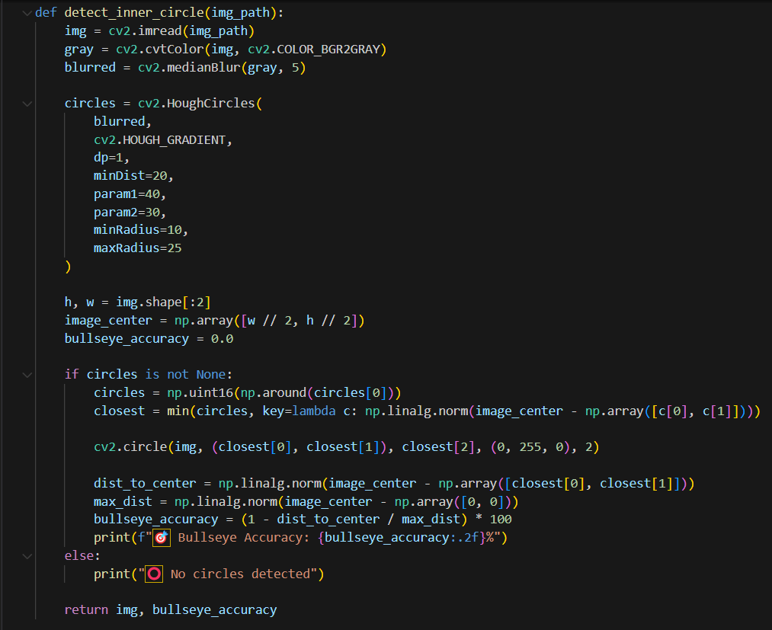

**Model Validation and Evaluation Report**

The trained model was evaluated on the test dataset. The results are summarized below:

**Model Classification Report (MobileNetV2)**

|  |  |  |  |  |
| --- | --- | --- | --- | --- |
| **class** | **precision** | **Recall** | **F1 -score** | |
| Bulls Eye | 0.83 | 0.83 | 0.83 | |
| Not Bulls Eye | 0.45 | 0.45 | 0.45 | |
| Macro Avg | 0.64 | 0.64 | 0.64 | |
| Weighted Avg | | | | 0.70 | |
| Accuracy | | | | 0.75 | |

